Project Plan

Soccer Connect

Industry Partner
Primary Instructor | Anjana Shah
Team Member | Kathan Parikh
Team Member | Laurence Liang
Team Member | Steven Nguyen
Team Member | Kenan Odongo
Team Member | Soroush Salari

Document Revision History

Revision # | Date
2.0 | 24/01/26

Table of Contents

- Executive Summary
- Project Approvers, Reviews and Distribution List
- Scope
- Deliverables
- Assumptions
- Dependencies
- Risk Management
- Communications
- Task Listing (WBS- Work Breakdown Structure)
- Gantt Chart
- Milestones
- RAM – Responsibility Assignment Matrix
- Approval
1. Executive Summary

The following describes the project to be executed.

Objective | The project known as Soccer Connect is a web/mobile application designed to streamline and enrich the soccer community experience within the Greater Toronto Area (GTA). The platform connects players, coaches, teams, and fans by centralizing essential soccer-related activities—ranging from tryouts and job postings to community networking and match logistics.
Corporate Goals Addressed
Planned Start Date | Monday, January 12, 2026
Planned End Date | Thursday, April 2, 2026

2. Project Approvers, Reviews and Distribution List

Approvers, reviewers and distribution list

Project Role | Name | E-mail | Date
Reviewer | Anjana Shah | ashah@georgebrown.ca | 15/09/25
Approver | Steven Nguyen, Kathan Parikh,  Kenan Odongo, Laurence Liang, Soroush Salari | Steven.nguyen@georgebrown.ca  Kathan.parikh@georgebrown.ca  Kenan.odongo@georgebrown.ca  laurenceliang@georgebrown.ca  Soroush.salari@georgebrown.ca | 22/01/26
Participants | Steven Nguyen, Kathan Parikh,  Kenan Odongo, Laurence Liang,  Soroush Salari | Steven.nguyen@georgebrown.ca  Kathan.parikh@georgebrown.ca  Kenan.odongo@georgebrown.ca  laurenceliang@georgebrown.ca  Soroush.salari@georgebrown.ca | 22/01/26

3. Scope

Define the sum total of all of its products and their requirements or features.

In Scope | Out of Scope
Allow users to message each other individually or in a group chat | Video streaming of soccer games
Allow users to view and book play spaces/fields | Video chatting
Account following
Purchasing of premium account
Payment Processing
Account login
Database interactions
Soccer organizations can post job/staffing opportunities
Soccer organizations can post tryouts
Posting Advertisements
Team creation and management

4. Deliverables

This project will deliver the following.

Deliverable | Description
User Authentication | Implement account creation, login, and password recovery. Includes user registration, login functionality, and error handling for invalid inputs.
Messaging Feature | Enable real-time messaging for 1-on-1 and group chats. Includes group creation, message sending, and push notifications.
Team Creation and Management | Allow users to create teams, invite members, and manage team rosters. Features include team creation, member invitations, and team settings.
Booking Play Spaces/Fields | Allow users to view available fields and book them. Includes field availability management, booking system, and optional calendar integration.
Soccer Organization Features | Enable soccer organizations to post job/staffing opportunities and tryouts. Includes job listings and tryout announcements.

5. Assumptions

This project makes the following assumptions;

- That most of the user base can navigate electronic devices such as computers and mobile devices without much assistance.
- Since the application is community driven, there will be sufficient interest in it to support continued development/engagement as well as attracting corporate stakeholders to partner with it.
- Features offered are desirable to users and are engaged frequently.
- Data storage and security will comply with industry standards and best practices.
- The application will develop as planned and there will be no deviation in core features and no out of scope features will be implemented initially.
- Organizations will be willing to open job/staff opportunities to users of the application, as well as available play spaces being open to bookings and events.

6. Dependencies

The following are the internal and external dependencies that will have to be acknowledged and addressed;
• People
- Development team (frontend, backend, UI/UX)
- QA testers for feature validation
- Users for testing (e.g., players, coaches, organizations)
• Resources
- Cloud hosting services (e.g., Firebase, AWS)
- Database system (e.g., PostgreSQL, MongoDB)
- Messaging API/service (e.g., Firebase Realtime DB, Socket.IO)
- Devices for testing (phones, tablets)
- Design tools (e.g., Figma)
• Government Regulations
- Data privacy laws (e.g., GDPR, PIPEDA)
- Terms of service and user consent policies
- Payment compliance (if premium accounts/payment features are added later)
• Hosting Platform
- Reliable up time and scalability
- Support for CI/CD pipelines
- Security certifications (e.g., SOC 2, ISO 27001)
• Database Services
- Scalable and secure data storage
- Backup and disaster recovery options
- Support for real-time updates (if needed)
• Third-Party APIs
- API reliability and documentation quality
- Rate limits and usage policies
- Licensing and cost implications
• User Testing Group
- Recruitment of representative test users
- Feedback collection tools and surveys
- NDA agreements (if applicable)
• Development Tools
- Version control (e.g., Git, GitHub/GitLab)
- Task/project management tools (e.g., Jira, Trello)
- Code editors/IDEs (e.g., VS Code)
• Network Connectivity
- Stable internet for development and testing
- VPNs or proxies (if accessing restricted services/APIs)
- Monitoring tools for connectivity issues
7. Risk Management

Potential Risk | Severity (H/M/L) | Likelihood (H/M/L) | Management Strategy
Person Hours | H: Over 100 hours | Moderate | Reassignment of team members, reassignment of tasks
Project Scope Creep | L: Project scope defined, subject to revision | M: As new techniques/features are learned they potentially could be implemented | Scope initially defined re-examined on a bi-weekly basis
Knowledge Levels of Users | L: Features developed could be seen as unnecessary for userbase | H: Only one team member is an active member of the userbase | Conducting interviews, social media research
Timeline Estimates Unrealistic | M: Team is unable to meet planned deadlines. | M: Timeline does not consider unexpected events. | Timeline reviewed by team, team members may have to reprioritize to focus on the project.
Absence of commitment level | M: Affects team morale, affects deliverables | Moderate | Frequently seek feedback to  ensure continued support
Project Team Availability | M: Distributed team  makes availability  questionable | M: Team members may have other obligations that affect time to work on project. | Continuous review of project  momentum by team. Identify any  impacts caused by  unavailability. If necessary,  increase commitment by  participants
Lack of technical knowledge from team | M: Deliverables will not be completed/not work as intended. | M: Level of understanding of coding and development tools different among team members | Training sessions, team members supporting one another, team member task reallocation.

8. Communication

Reporting

The following reports will be produced;

Report | Audience | Frequency
Minutes of Meetings | Professor | Per meeting
Status Reports | Professor | Per Sprint

Meetings

The following meetings/communication will be established;

Meeting | Purpose | Attendees | Frequency
Sprint progress meeting | For the team members to inform each other of progress on sprint tasks started/continued from the previous sprint. Also, an opportunity to ask for help amongst team members. | Team members | One-two times a week
Capstone Project Lab Sessions | An additional opportunity for the team members to meet and discuss work to be done, update progress, and ask the professor anything related to the project | Team members, professor | Once a week

9. Task Listing (WBS- Work Breakdown Structure)
The following resource proposal template summarizes the resource hours committed to this project, upon final approval of this document.

Reference | Tasks | Duration | Dependency
A | Soccer club type user can post/manage team tryouts. | 12 hours | B
B | Set up database(s) for user profile information, user posts, etc. | 24 Hours
C | User profile including the ability to post player stats | 2 Hours | B
D | Create an updatable list of field/play spaces that users can book. | 12 Hours | B
E | Booking of field/play spaces with timeslots and calendar | 24 Hours | D, B
F | Soccer club type user can post/manage job openings. | 12 Hours | B
G | User Direct Messages | 6 Hours
H | Group chat | 24 Hours | G
I | Team creator and manager | 20 Hours | B
J | User interface improvements | 6 Hours

10. Gantt Chart
Create a detailed Gantt Chart from your Task Listing(Use any software tool and paste the image or upload as a separate file that can be opened as pdf/doc/xls)

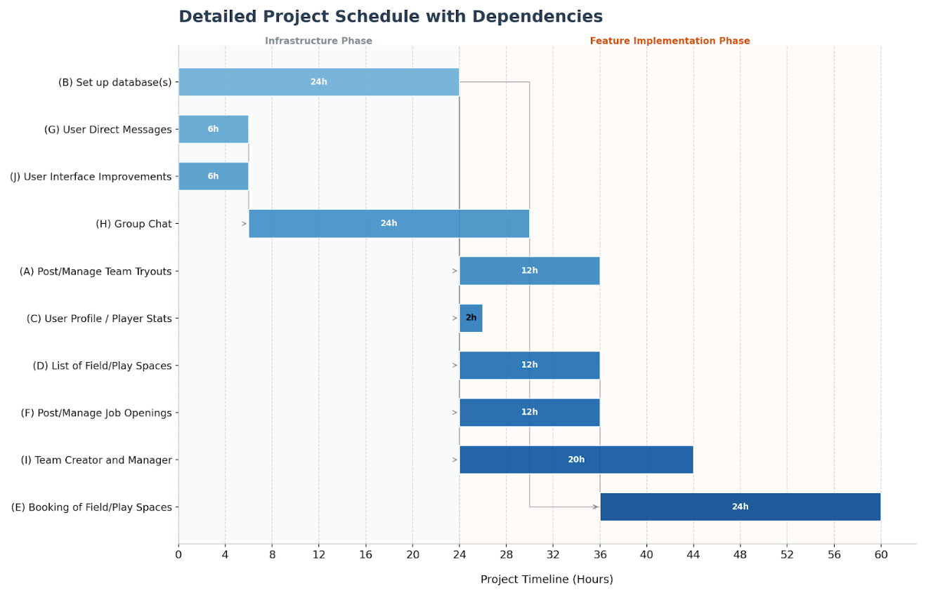

11. Milestones

Major Activity or Milestone | Estimated Milestone Target date | Owner/Reviewer Team Members
Database Setup | February 1, 2026 | Steven, Laurence
Field/Play Space Management | March 6, 2026 | Steven
Team Management | March 6, 2026 | Laurence, Kathan
Communication (Direct Messaging, Group Chat) | February 20, 2026 | Kathan, Kenan
Post/Manage Job Openings/Team Tryouts | February 13, 2026 | Kenan

12. RAM – Responsibility Assignment Matrix

Task | Soroush | Laurence | Kenan | Steven | Kathan
Post/Manage Job Openings/Team Tryouts | S |  | P
Database Setup |  | S |  | P
User/Admin Profile |  |  | S
Field/Play Space Management | S |  |  | P
Communication |  |  | P |  | P
Team Management |  | P |  |  | P
User Interface | S | S | S | S | S

P = Primary
S = Secondary

13. Approval

The signatures below indicate their approval of the contents of this document.

Project Role | Name | Signature | Date
Technical Requirements Lead | Soroush Salari | Soroush Salari | 23rd Jan. 2026
Project Vision Lead | Steven Nguyen | Steven Nguyen | 23rd Jan. 2026
Vision Collaborator & Meeting Manager | Laurence Liang | Laurence Liang | 23rd Jan. 2026
User Experience Lead | Kenan Odongo | Kenan Odongo | 23rd Jan. 2026
Quality Assurance Lead | Kathan Parikh | Kathan Parikh | 23rd Jan. 2026

